***CSA1006:-SOFTWARE ENGINEERING WITH DATA ANALYTICS***

***Name: Y.YAMINI REDDY***

***Reg.no: 192211153***

**1Q. Draw a USE-CASE diagram for Online Voting System using CASE tools**

***Aim:*** To draw a use case diagram for online voting system using case tools.

***Software Used:*** Umbrello.

***Diagram:***

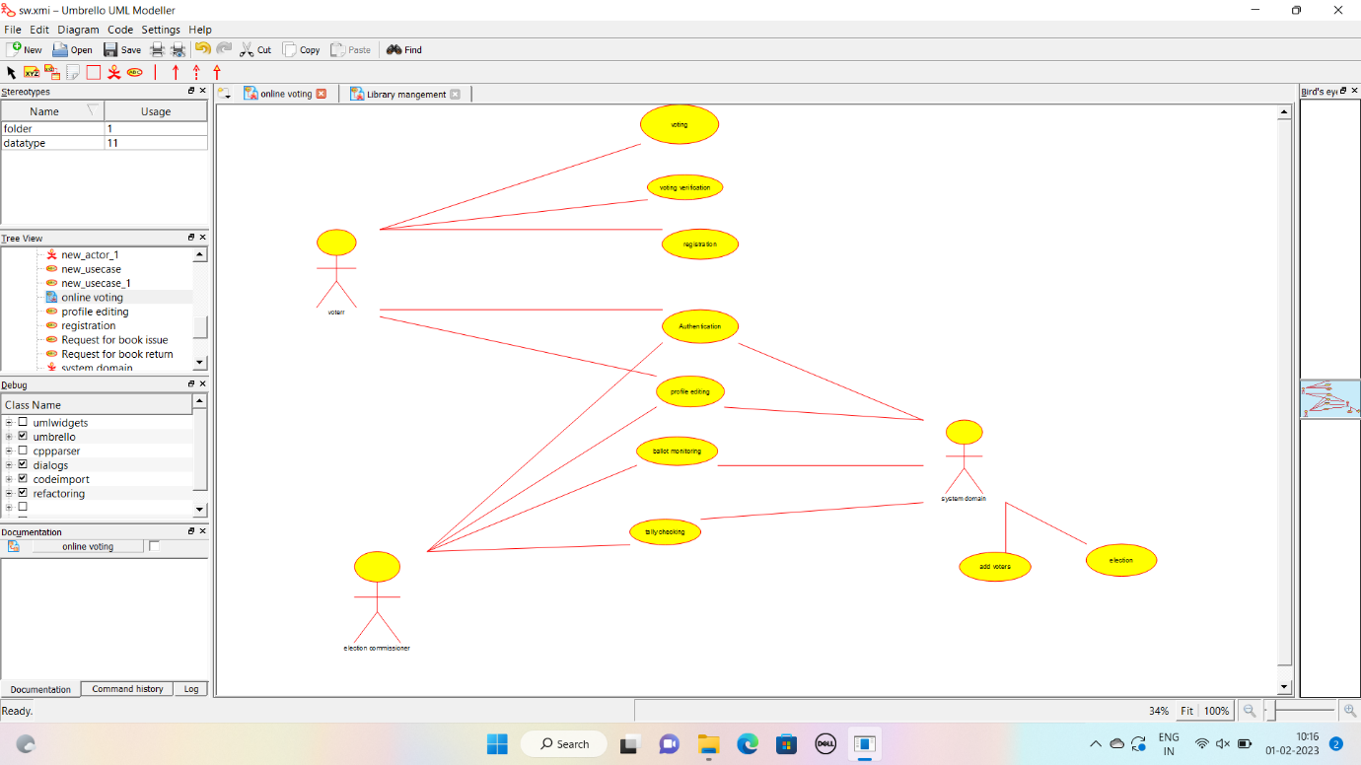

**Result:** Drawing a use case diagram for online voting system was completed successfully.

**2Q. Draw a USE-CASE diagram for Library Management System using CASE tools.**

**Aim:** To draw a use case diagram for library management system using case tools.

**Software Used:** Umbrello.

**Diagram:**

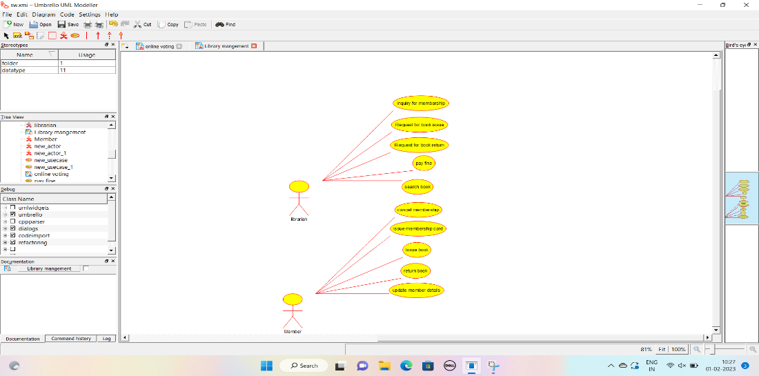

**Result:** Drawing a use case diagram for library management system was completed successfully.

**3Q. Draw and validate the flowchart to compute the quotient and remainder.**

**Aim:** To draw and validate the flowchart to compute the quotient and remainder.

**Software Used:** Raptor.

**Diagram:**

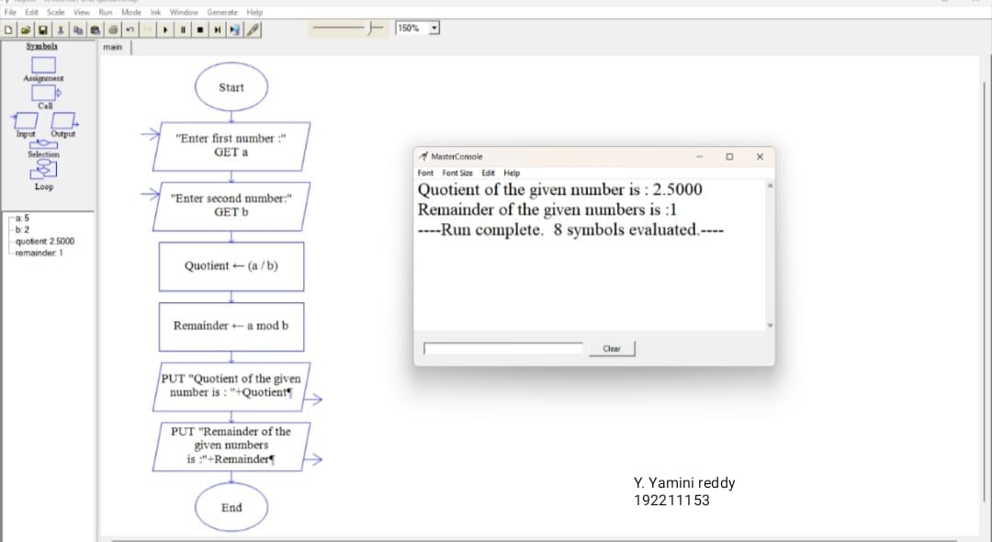

**Result:** Flowchart to compute the quotient and remainder was completed and output verified.

**4Q. Draw a USE-CASE diagram for Online Shopping system using CASE tools.**

**Aim:** To draw a use case diagram for online shopping system.

**Software Used:** Umbrello.

**Diagram:**

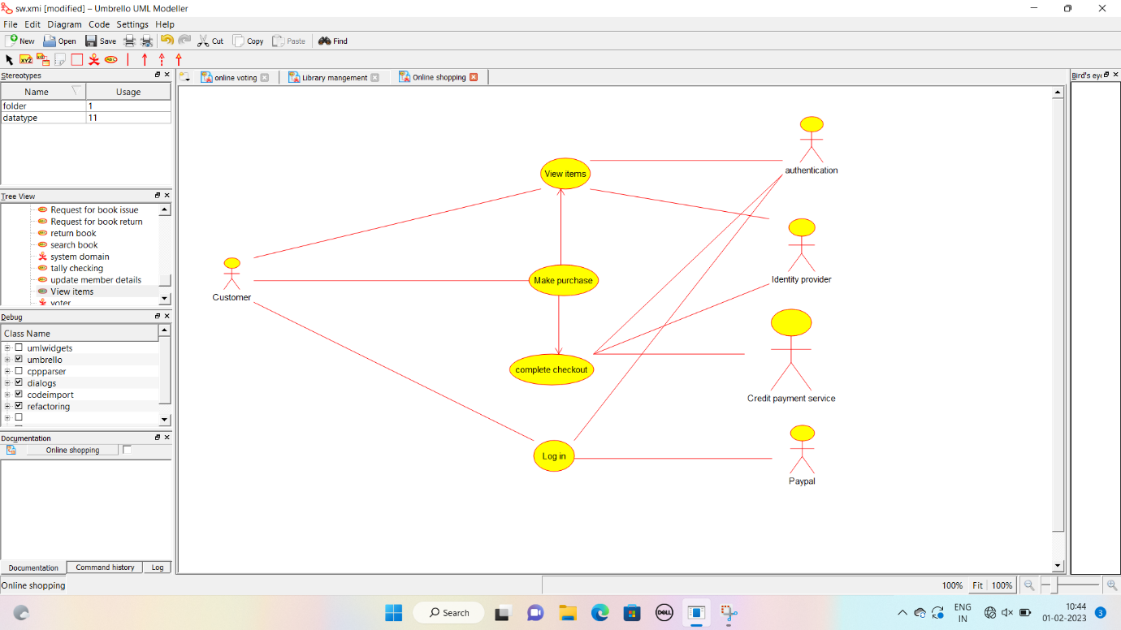

**Result :** Drawing of use case diagram for online shopping voting system was successfully completed.

**5Q. Draw a USE-CASE diagram for Online Railway Reservation System using CASE tools.**

**Aim:** To draw a use case diagram for online railway reservation system.

**Software Used:** Umbrello.

**Diagram:**

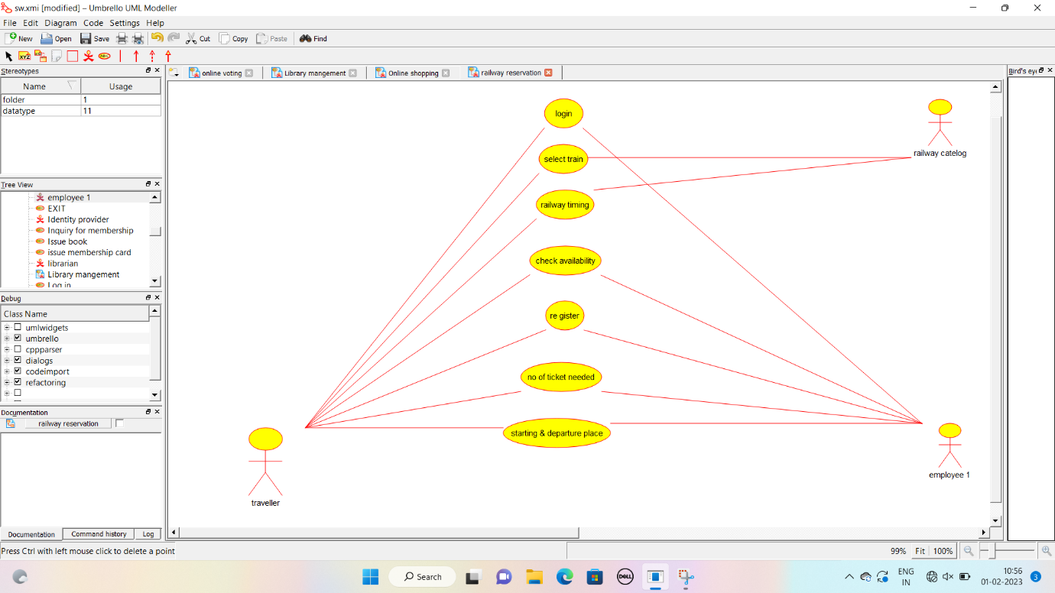

**Result :** Use case diagram for online railway reservation system was successfully completed.

**6Q. Draw a USE-CASE diagram for Hospital Management System using CASE tools.**

**Aim:** To draw a use case diagram for hospital management system.

**Software Used:** Umbrello.

**Diagram:**

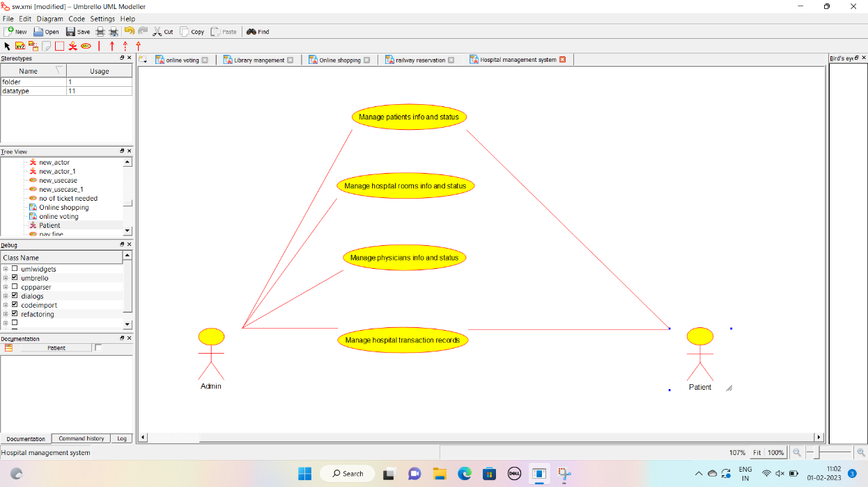

**Result :** Use case diagram for hospital management system was successfully completed.

**7Q. Draw a USE-CASE diagram for ATM System using CASE tools.**

**Aim:** To draw a use case diagram for ATM system.

**Software Used:** Umbrello.

**Diagram:**

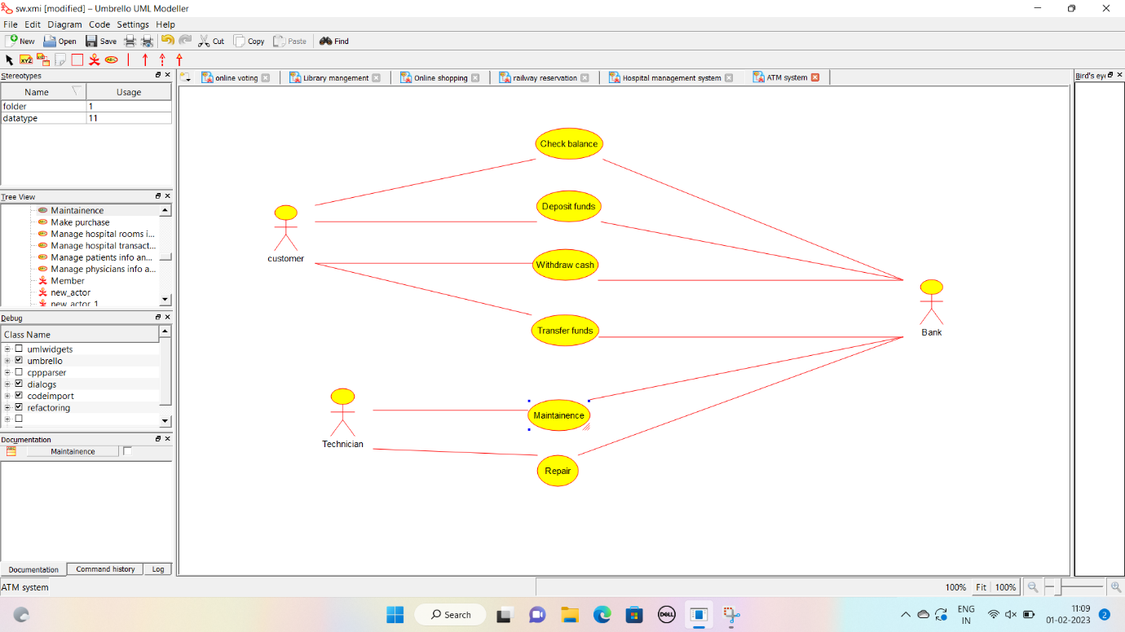

**Result :** Use case diagram for ATM system was completed successfully.

**8Q. Draw a USE-CASE diagram for Online college management System using CASE tools.**

**Aim:** To draw a use case diagram for online college management system.

**Software Used:** Umbrello.

**Diagram:**

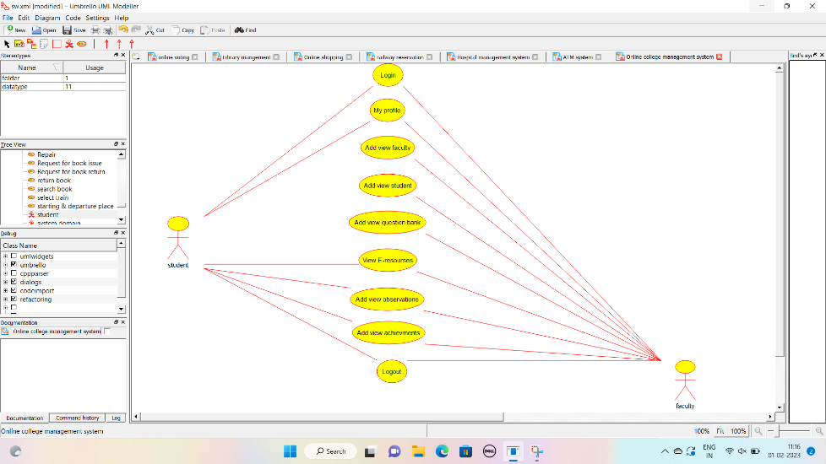

**Result :** Use case diagram for online college management system was successfully completed.

**9Q. Draw a USE-CASE diagram for Online Airline Reservation System using CASE tools.**

**Aim:** To draw a use case diagram for online airline reservation system.

**Software Used:** Umbrello

**Diagram:**

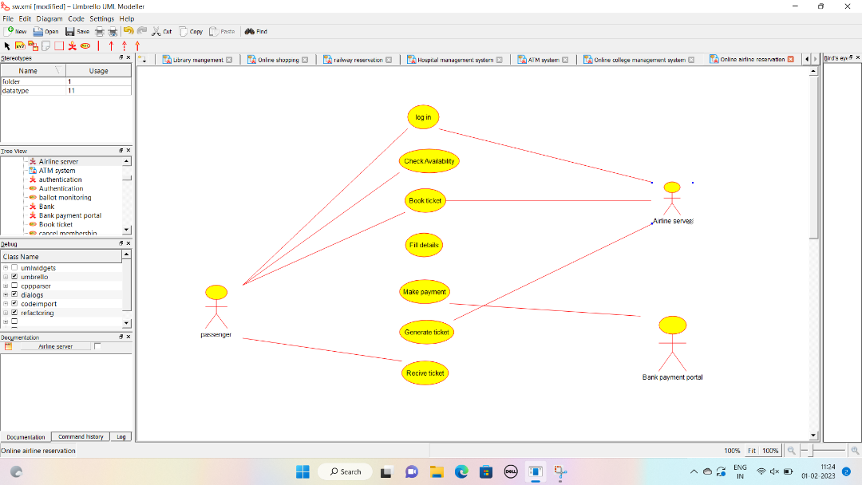

**Result:** Use case diagram for online airline reservation system was successfully completed.

**10Q. Draw a Class diagram for Online Airline Reservation System**

**using CASE tools.**

**Aim:** To draw a class diagram for online airline reservation system.

**Software Used:** Umbrello.

**Diagram:**

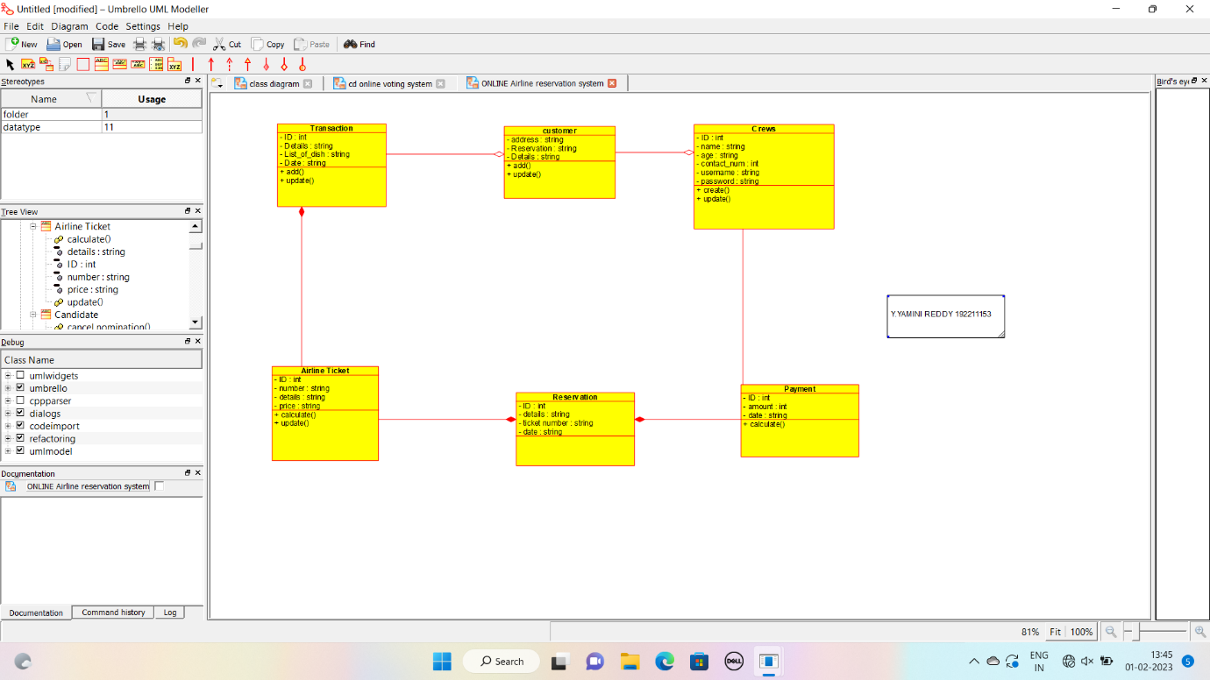

**Result:** Class diagram for online airline reservation system was successfully completed.

**11Q. Draw a Class diagram for Online Voting System using CASE tools**

**Aim:** To draw a class diagram for online voting system.

**Software Used:** Umbrello.

**Diagram:**

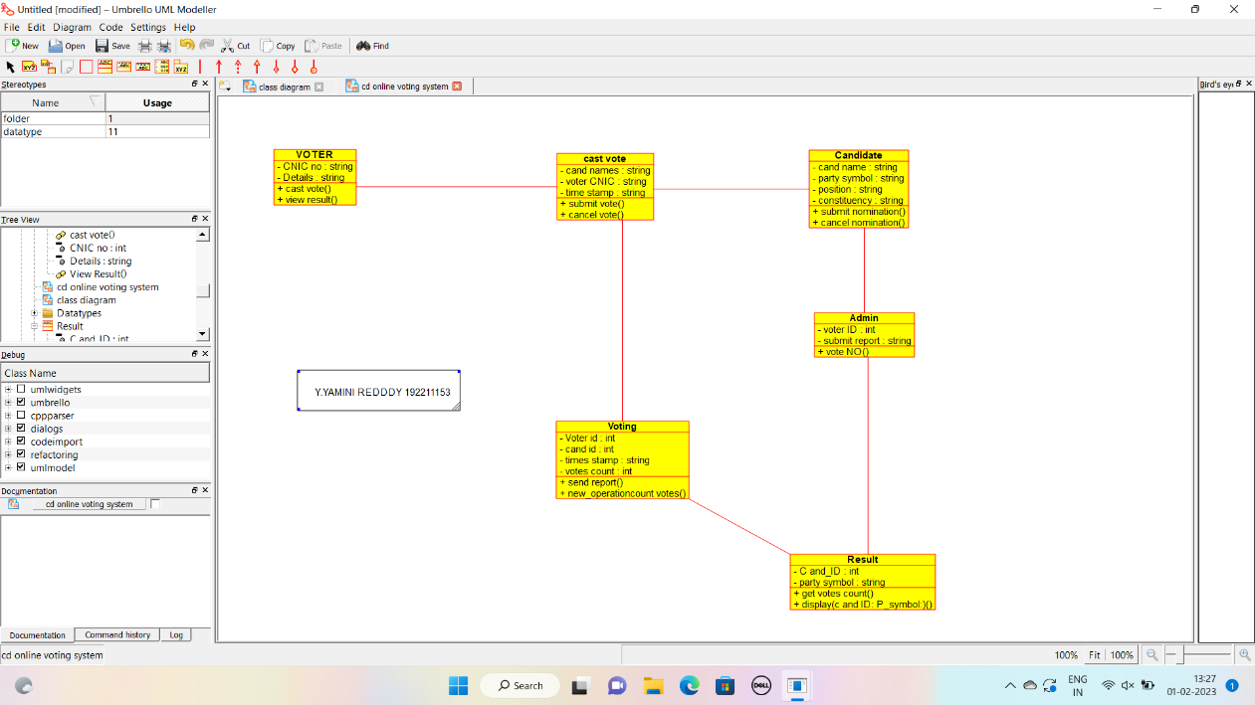

**Result:** Class diagram for online voting system was successfully completed.

**12Q. Draw a Class diagram for Library Management System using CASE tools.**

**Aim:** To draw a class diagram for library management system.

**Software Used:** Umbrello.

**Diagram:**

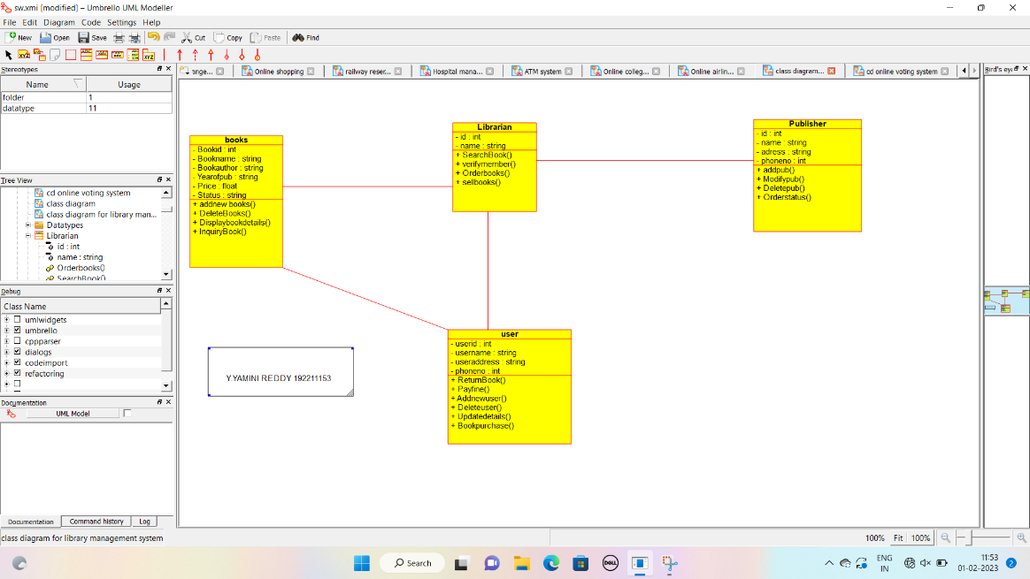

**Result:** Class diagram for library management system was successfully completed.

**13Q. Draw a Activity diagram for Online Voting System using CASE tools.**

**Aim:** To draw a activity diagram for online voting system.

**Software used:** Umbrello.

**Diagram:**

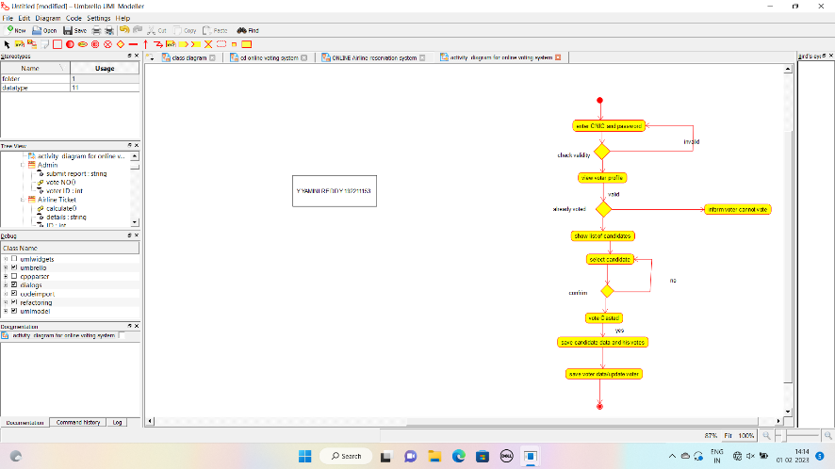

**Result:** Activity diagram for online voting system was successfully completed.

**14Q. Draw a Activity diagram for Library Management System using CASE tools.**

**Aim:** To draw a activity diagram for library management system

**Software used:** Umbrello.

**Diagram:**

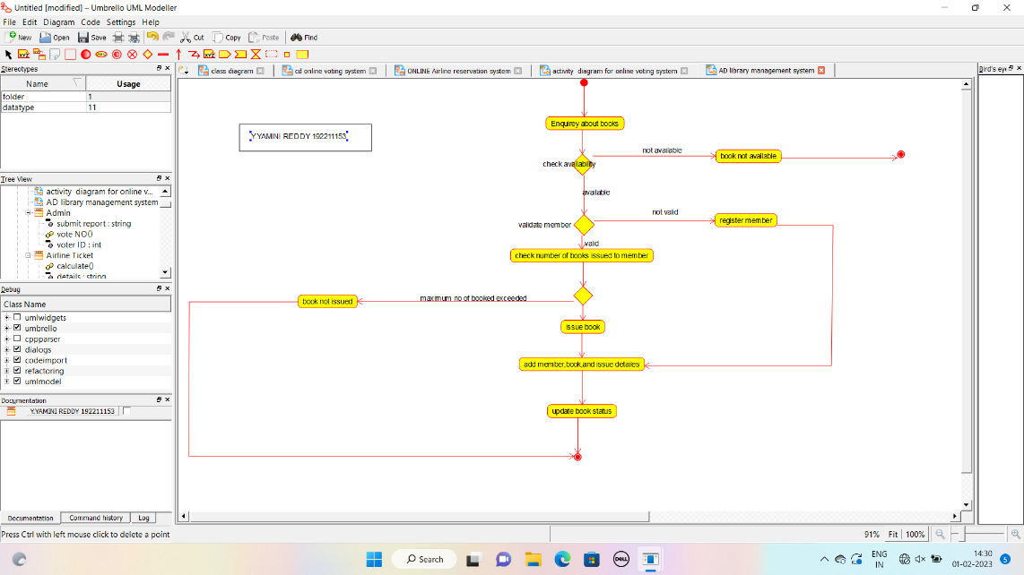

**Result:** Activity diagram for library management system was successfully completed.

**15Q. Draw a Activity diagram for Online Shopping system using CASE tools.**

**Aim:** To draw a activity diagram for online shopping system.

**Software used:** Umbrello.

**Diagram:**

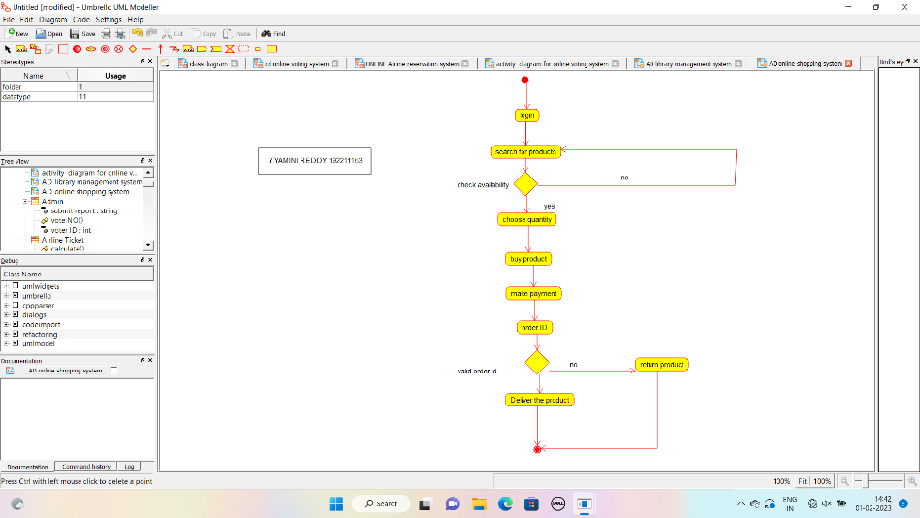

**Result:** Activity diagram for online shopping system was successfully completed.

**16Q. Draw a Activity diagram for Online Railway Reservation System using CASE tools.**

**Aim:** To draw a activity diagram for online railway reservation system.

**Software used:** Umbrello.

**Diagram:**

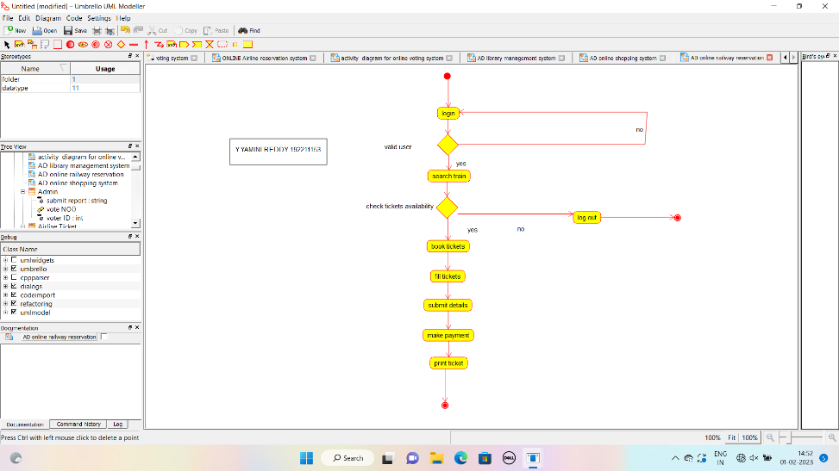

**Result:** Activity diagram for online railway reservation system was successfully completed.

**17Q. Draw a Activity diagram for Hospital Management System using CASE tools.**

**Aim:** To draw a activity diagram for hospital management system.

**Software used:** Umbrello.

**Diagram:**

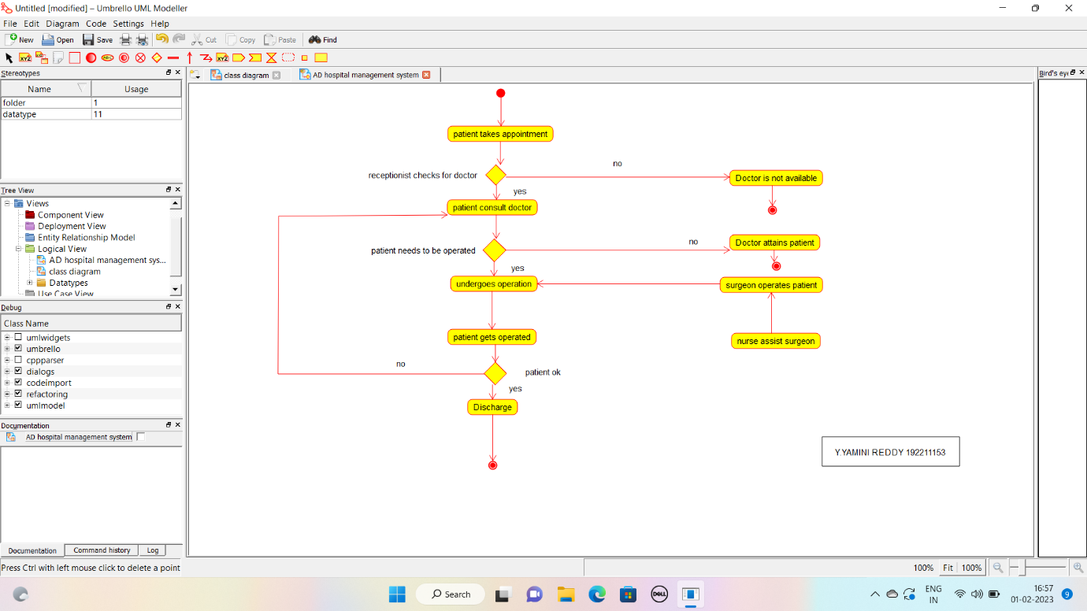

**Result:** Activity diagram for hospital management system was successfully completed.

**18Q. Using Raptor- Draw the flowchart to check whether the given number is a palindrome or not.**

**Aim:** To draw the flowchart to check whether the given number is a palindrome or not.

**Software used:** Raptor.

**Diagram:**

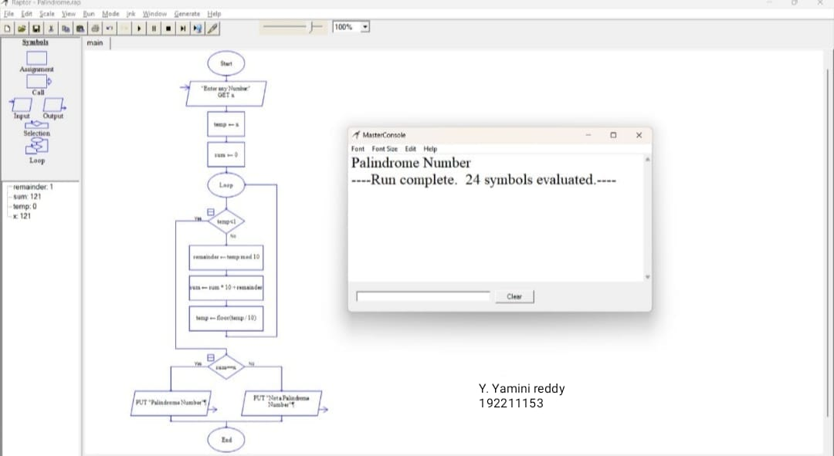

**Result:** Flowchart to check whether the given number is palindrome or not was completed and output verified.

**21Q. Using Raptor - Draw the flowchart to find whether the given number is prime or not.**

**Aim:** To draw the flowchart to find whether the given number is prime or not.

**Software used:** Raptor.

**Diagram:**

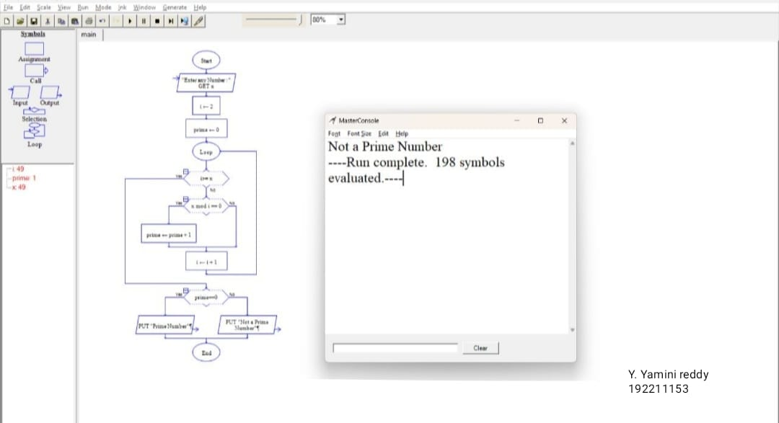

**Result:** Flowchart to find whether the given number is prime or not was completed and output verified

**22Q. Find Cyclomatic Complexity for a graph having number of edges as 17, number of nodes as 13 and number of predicate nodes in the flow graph as 5.**

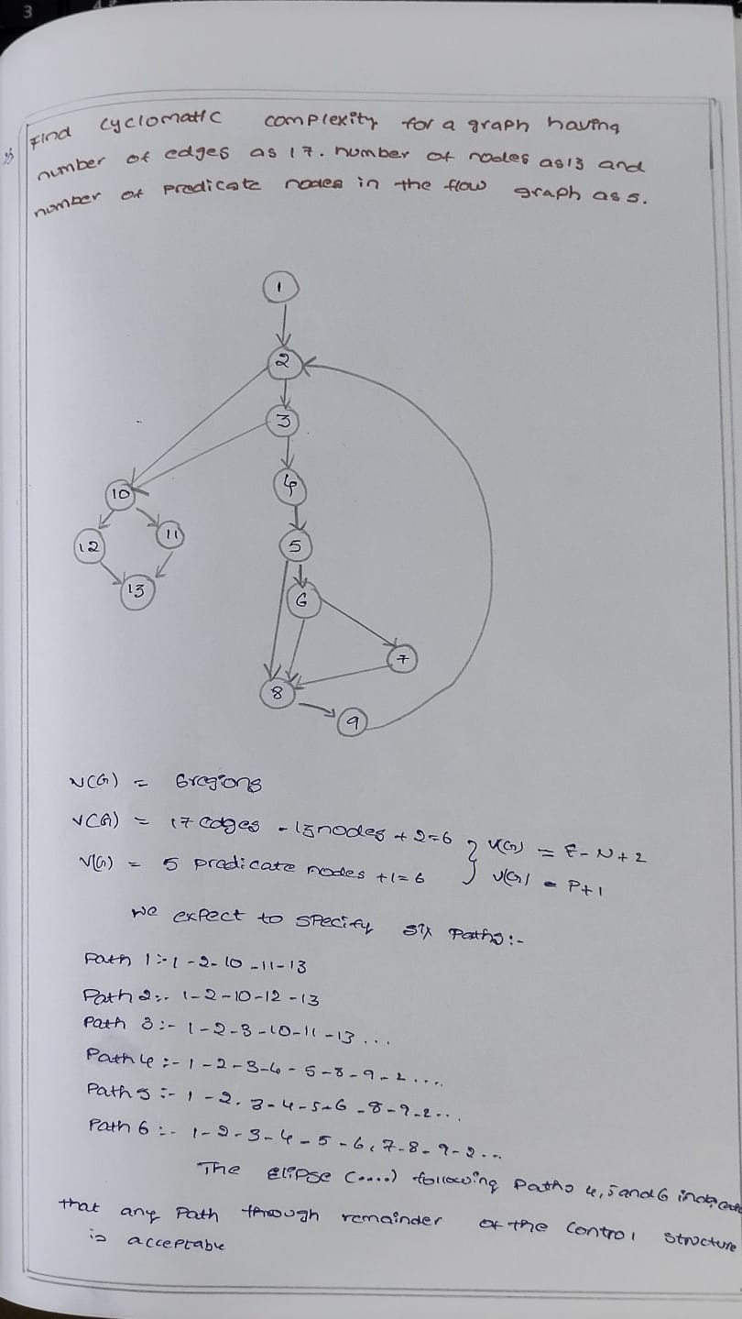

**23Q.Design an activity diagram for an automated online banking system which shows the flow of withdrawal,deposit and balance enquiry.**

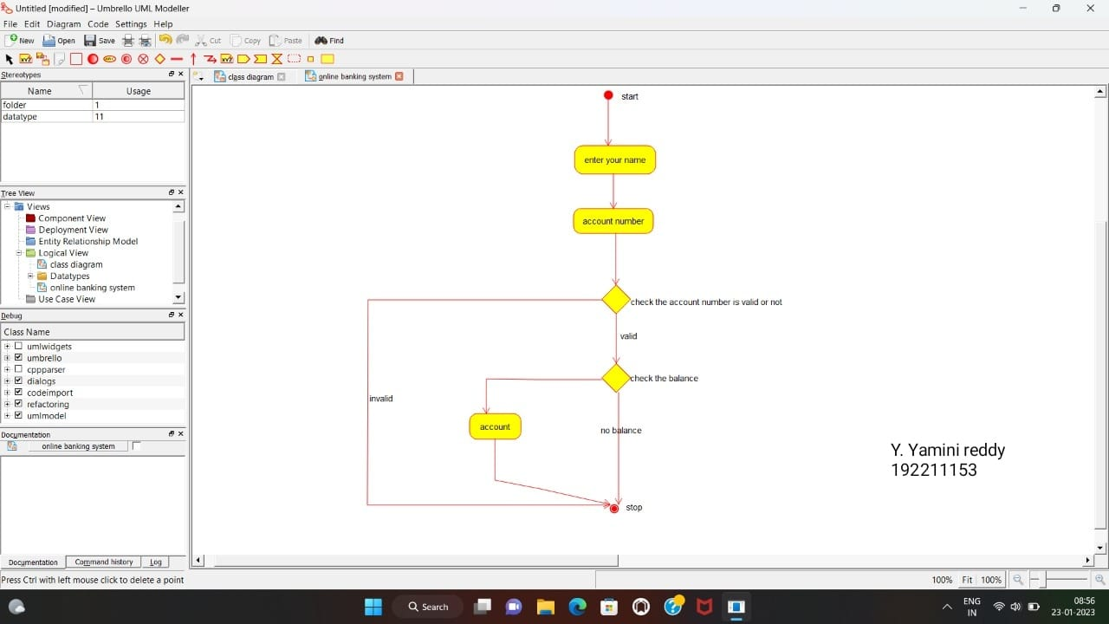

**24Q.Develop an activity diagram for an E-library online public access catalogue.the activities of the system are listed below.Patrons of a library can search library catalogue online to locate various resources-books,periodicals,audio and visuals materials,or other items under the control of the library.Patrons may reserve or renew items,provide feedback ,and mange their account.**

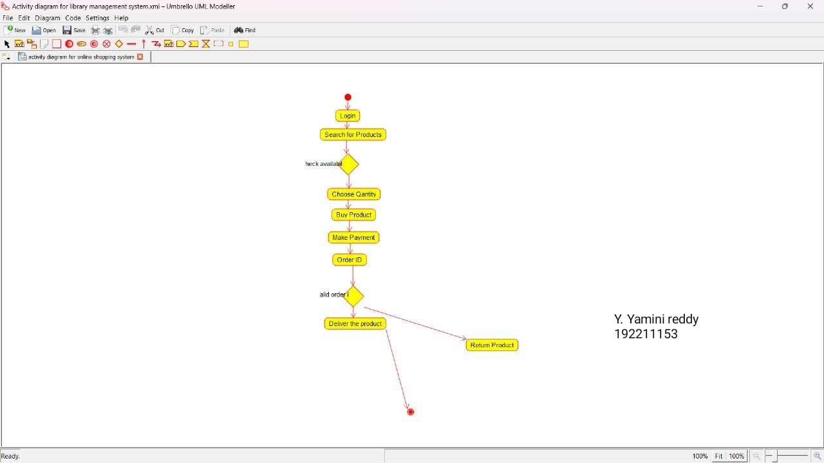

**25Q.Develop a class diagram for an E-library online public access catalogue.the activities of the system are listed below.Patrons of a library can search library catalogue online to locate various resources-books,periodicals,audio and visuals materials,or other items under the control of the library.Patrons may reserve or renew items,provide feedback ,and mange their account.**

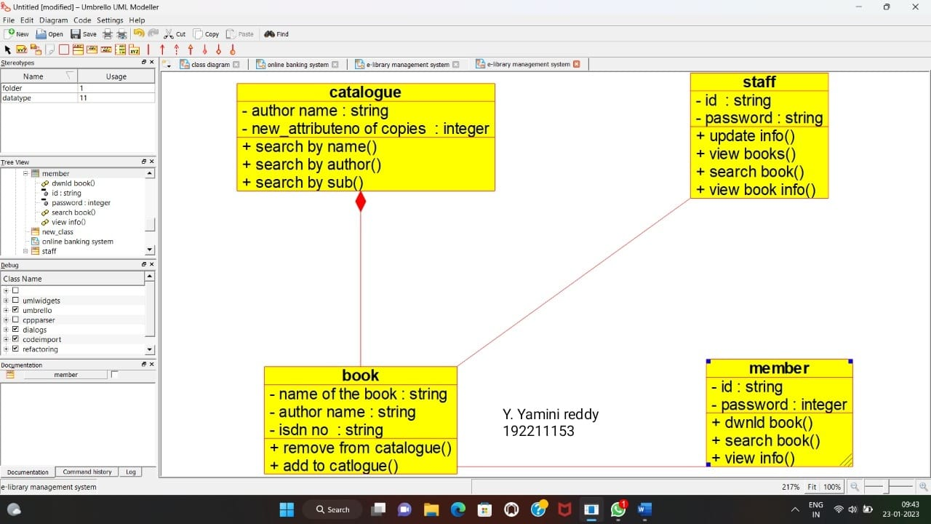

**26Q.Draw a use case diagram for a restaurant systems.The activites of the restaurant system are listed below.Receive the customer food orders,serve the customer with their ordered food,collect payment from customers,store customer payment details,order raw materials for food products,pay for raw materials and pay for labour.**

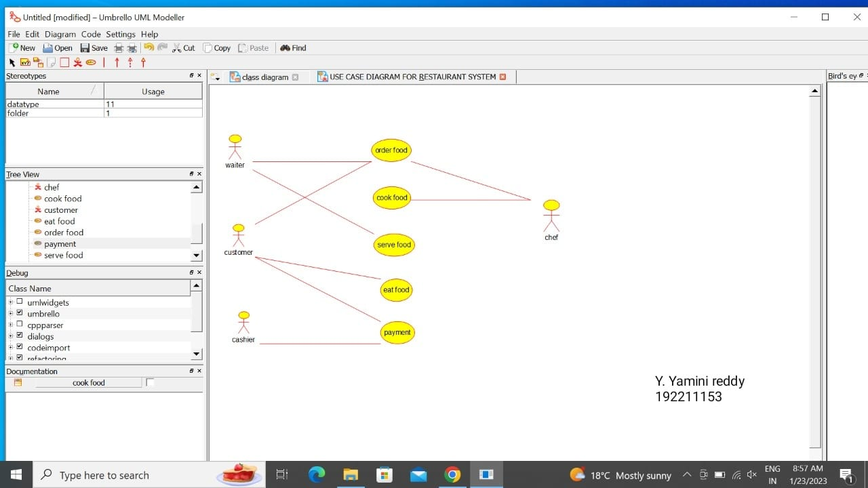

**27Q. Draw a class diagram diagram for a restaurant systems.The activites of the restaurant system are listed below.Receive the customer food orders,serve the customer with their ordered food,collect payment from customers,store customer payment details,order raw materials for food products,pay for raw materials and pay for labour.**

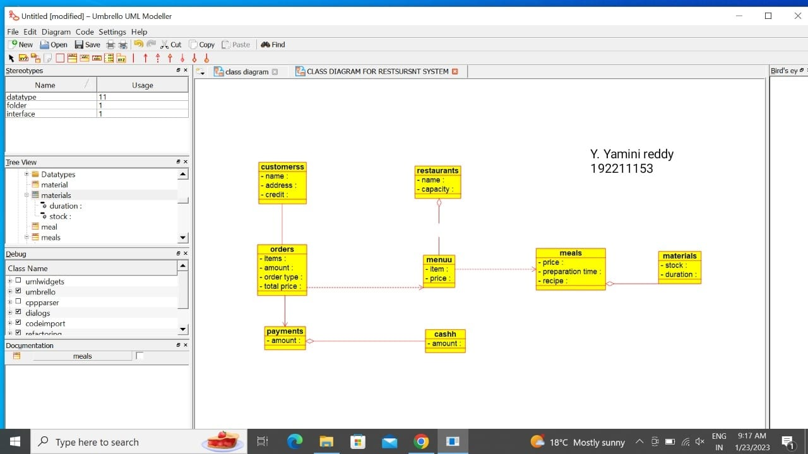

**28Q.Make a class diagram to model for a quiz system.A user can request a quiz system.A user can request a quiz for the system.The system picks a set of questions from its database, and composes them together to make a quiz.It rates the user’s answers and gives hits if the user requests it. In addition to users, we also have helpers who provide questions and hints. And also administrators who must certify questions to make sure they are not too trival, and that they are correct.**

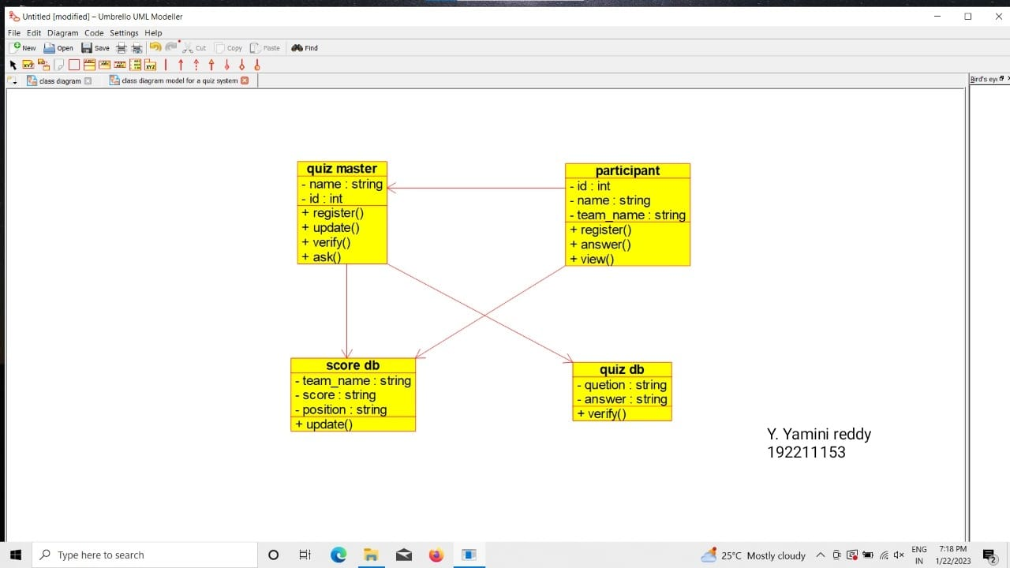

**29Q. .Draw a use case diagram to model for a quiz system.A user can request a quiz system.A user can request a quiz for the system.The system picks a set of questions from its database, and composes them together to make a quiz.It rates the user’s answers and gives hits if the user requests it. In addition to users, we also have helpers who provide questions and hints. And also administrators who must certify questions to make sure they are not too trival, and that they are correct.**

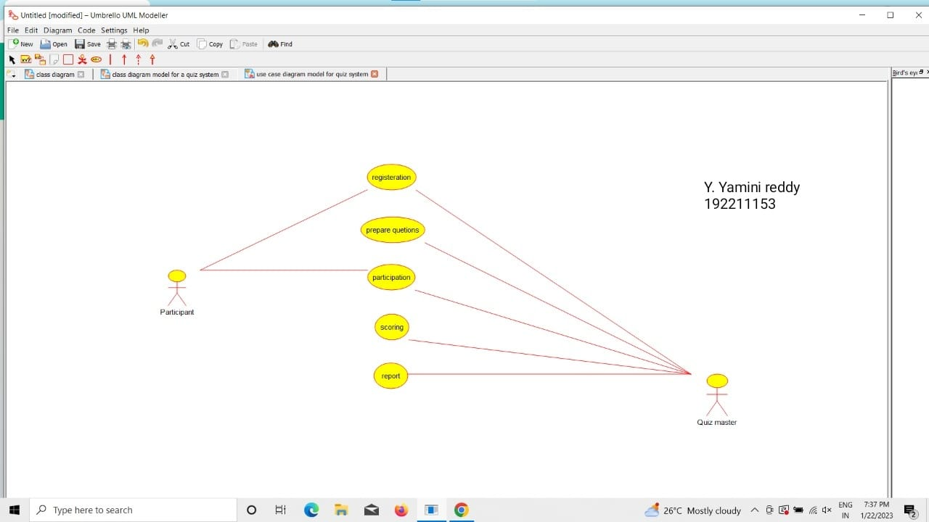

**30Q.Using Raptor-Draw and validate the flow chart to calculate factorial of a number.**

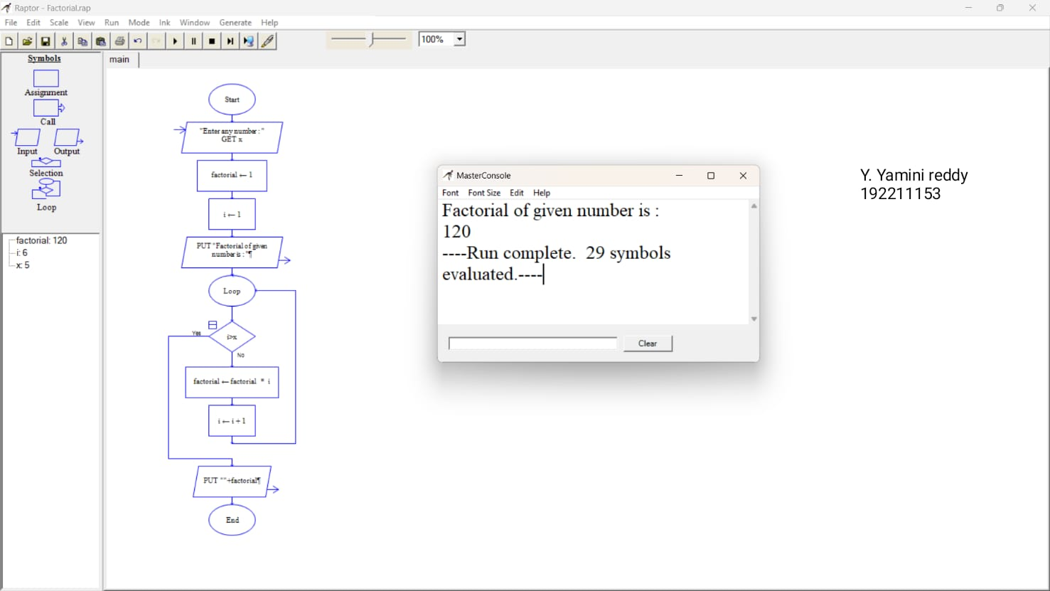

**31Q.Using Raptor-Draw and validate the flow chart to find even series of the given number.**

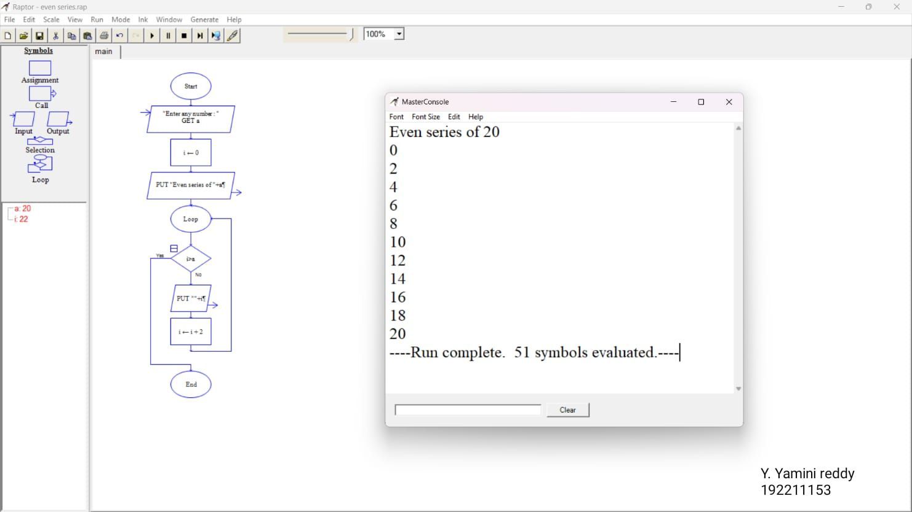

**32Q. .Using Raptor-Draw and validate the flow chart to display the reverse of the string.**

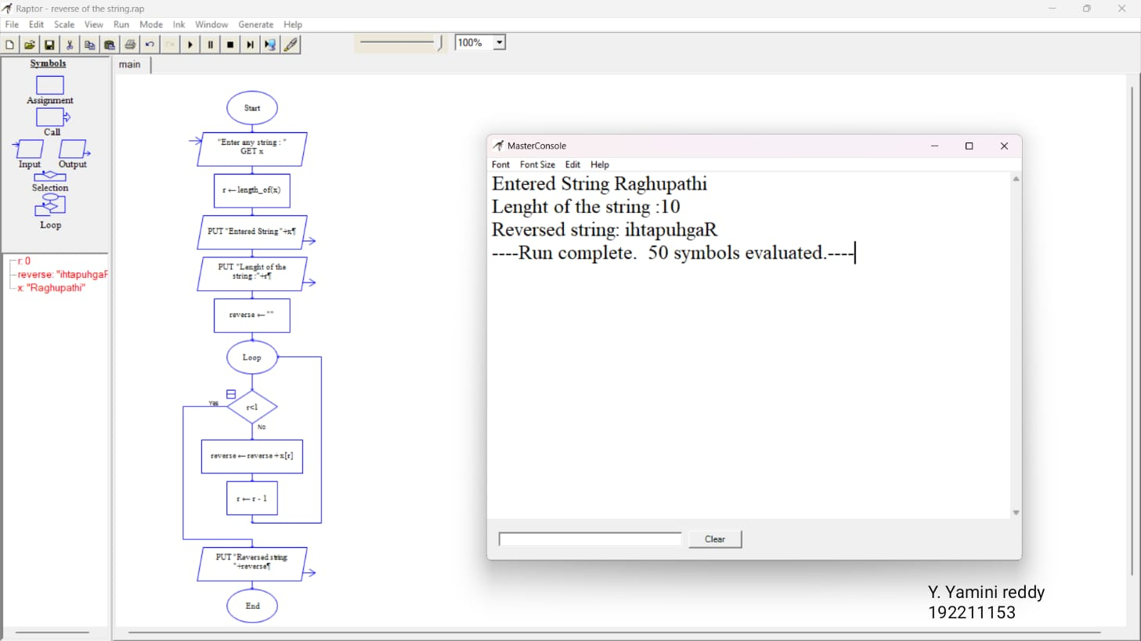

**33Q. Using Raptor-Draw and validate the flow chart to find largest of n Numbers.**

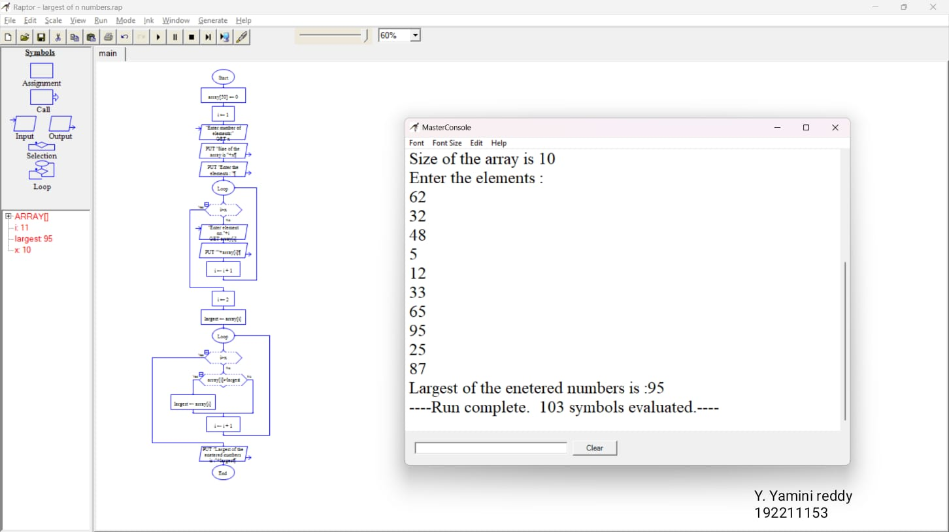

**34Q.Find cyclomatic complexity for a graph having number of edges as 20,number of nodes as 15 and number of predicate nodes in the flow graph as 4.**

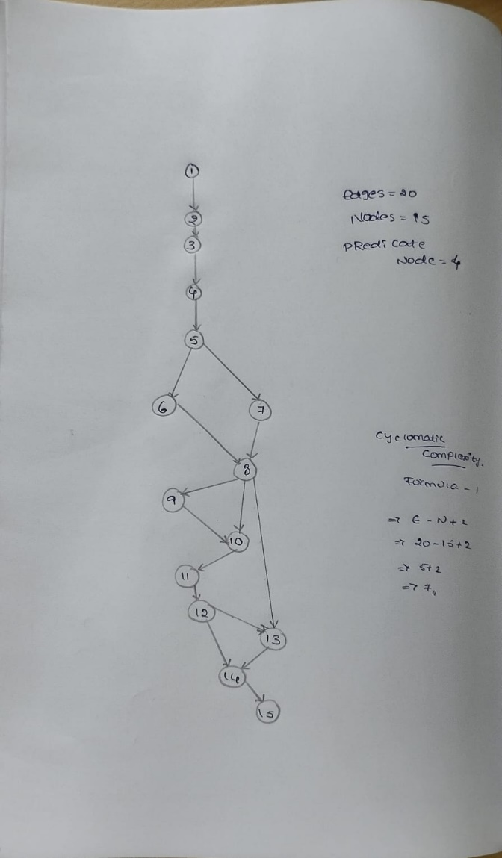

**35Q. Using Raptor- Draw and validate the flowchart to calculate Fibonacci series.**

**Aim:** To draw and validate the flowchart to calculate Fibonacci series.

**Software used:** Raptor.

**Diagram:**

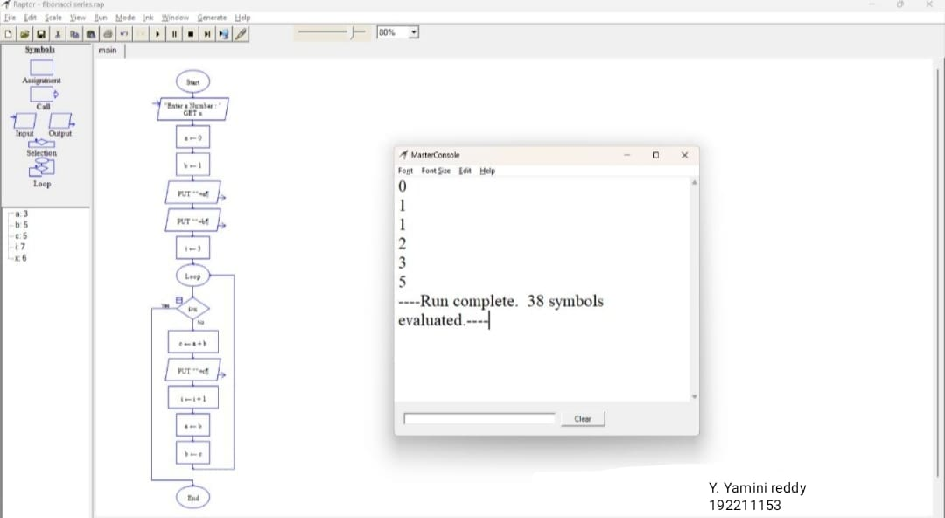

**Result:** Flowchart to calculate Fibonacci series was completed and output verified

**36Q.using Raptor-Draw the flowchart to find smallest of n Numbers.**

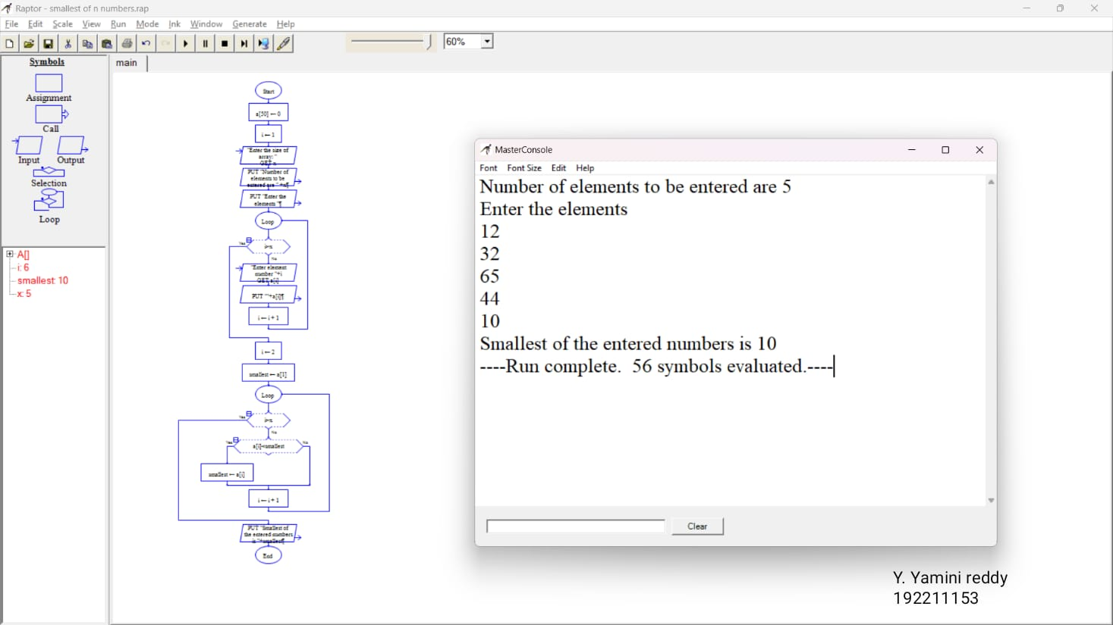

**37Q.Draw use case diagram for E-wallet online prepaid account.**

**Aim:**To draw a use case diagram for E-wallet online prepaid account

**Software used:**umbrello

**Diagram:**

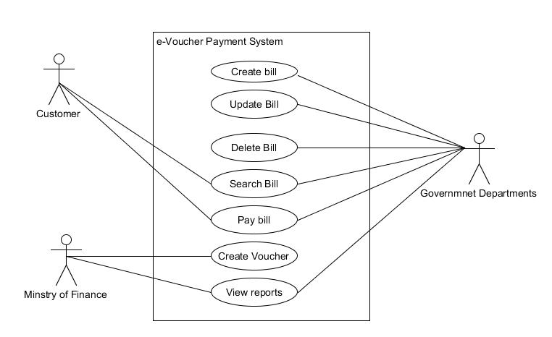Y. Yaminireddy 192211153

**Result:** use case diagram for E-wallet online prepaid account was completed successfully.

**38Q. Draw a class diagram for online security management system**

**Aim:**To draw a class diagram for online security management system

**Software used:**umbrello

**Diagram:**

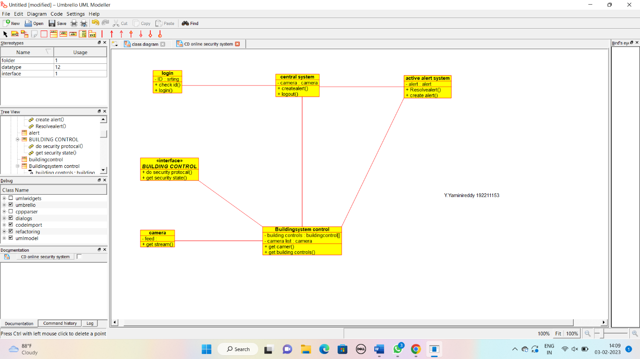

**Result:** Class diagram for online security management system was successfully completed

**39Q. . Draw a Class diagram for Online Voting System using CASE tools**

**Aim:** To draw a class diagram for online voting system.

**Software Used:** Umbrello.

**Diagram:**



**Result:** Class diagram for online voting system was successfully completed.

**40Q. 18Q. Using Raptor- Draw the flowchart to check whether the given number is a palindrome or not.**

**Aim:** To draw the flowchart to check whether the given number is a palindrome or not.

**Software used:** Raptor.

**Diagram:**



**Result:** Flowchart to check whether the given number is palindrome or not was completed and output verified.